Podger, Francis Denis (Frank), Dr
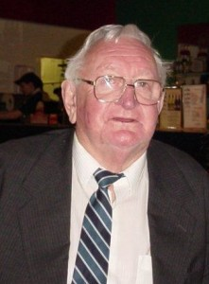

Graduated from Australian Forestry School 1955. Completed a MSc. Thesis “Aetiology of Jarrah Dieback” Master of Science in Forestry, University of Melbourne, 1968. Completed PhD. Worked in Dwellingup with Forests Department from c1956. In Research and also involved with the forest cadet school c1956-59. Resigned from Forests Department 12.6.1959 and joined CSIRO. Worked in WA and Tasmania ? In 1980s left CSIRO and did some consulting, including with CALM. Was at CALM Como in late 1980s. Worked for Department of Primary Industry in 1980s.
Other information: The first noted impact attributed to dieback disease was observed in 1921 within jarrah forests located at Karragullen, where increased patches of healthy jarrah forest were dying. Francis Denis (Frank) Podger was one of a team of people, including George Zentmyer, whom in 1964 identified the root-rot fungus, Phytopthora cinnamomi, as the cause of crown die-back in Western Australian forests. In 1996 he was chair of the Western Australian Dieback Review Panel, reporting on dieback in Western Australia.
Hansard WA Parliament 10.3.1988: CALM is contracted to Environment Australia to prepare a draft National Threat Abatement Plan for Phytophthora spp. Dr Podger is sub-contracted to CALM to write the draft in consultation with representatives from each State. Dr Podger also provides general advice to CALM on dieback related matters.

Biographical entry Podger, Francis Denis (1933 - 1999) (in Encyclopaedia of Australian Science website)
Born 10 August 1933 Bunbury, Western Australia, Australia
Died 1999?
Occupation Forester
Alternative Names Podger, Frank

